



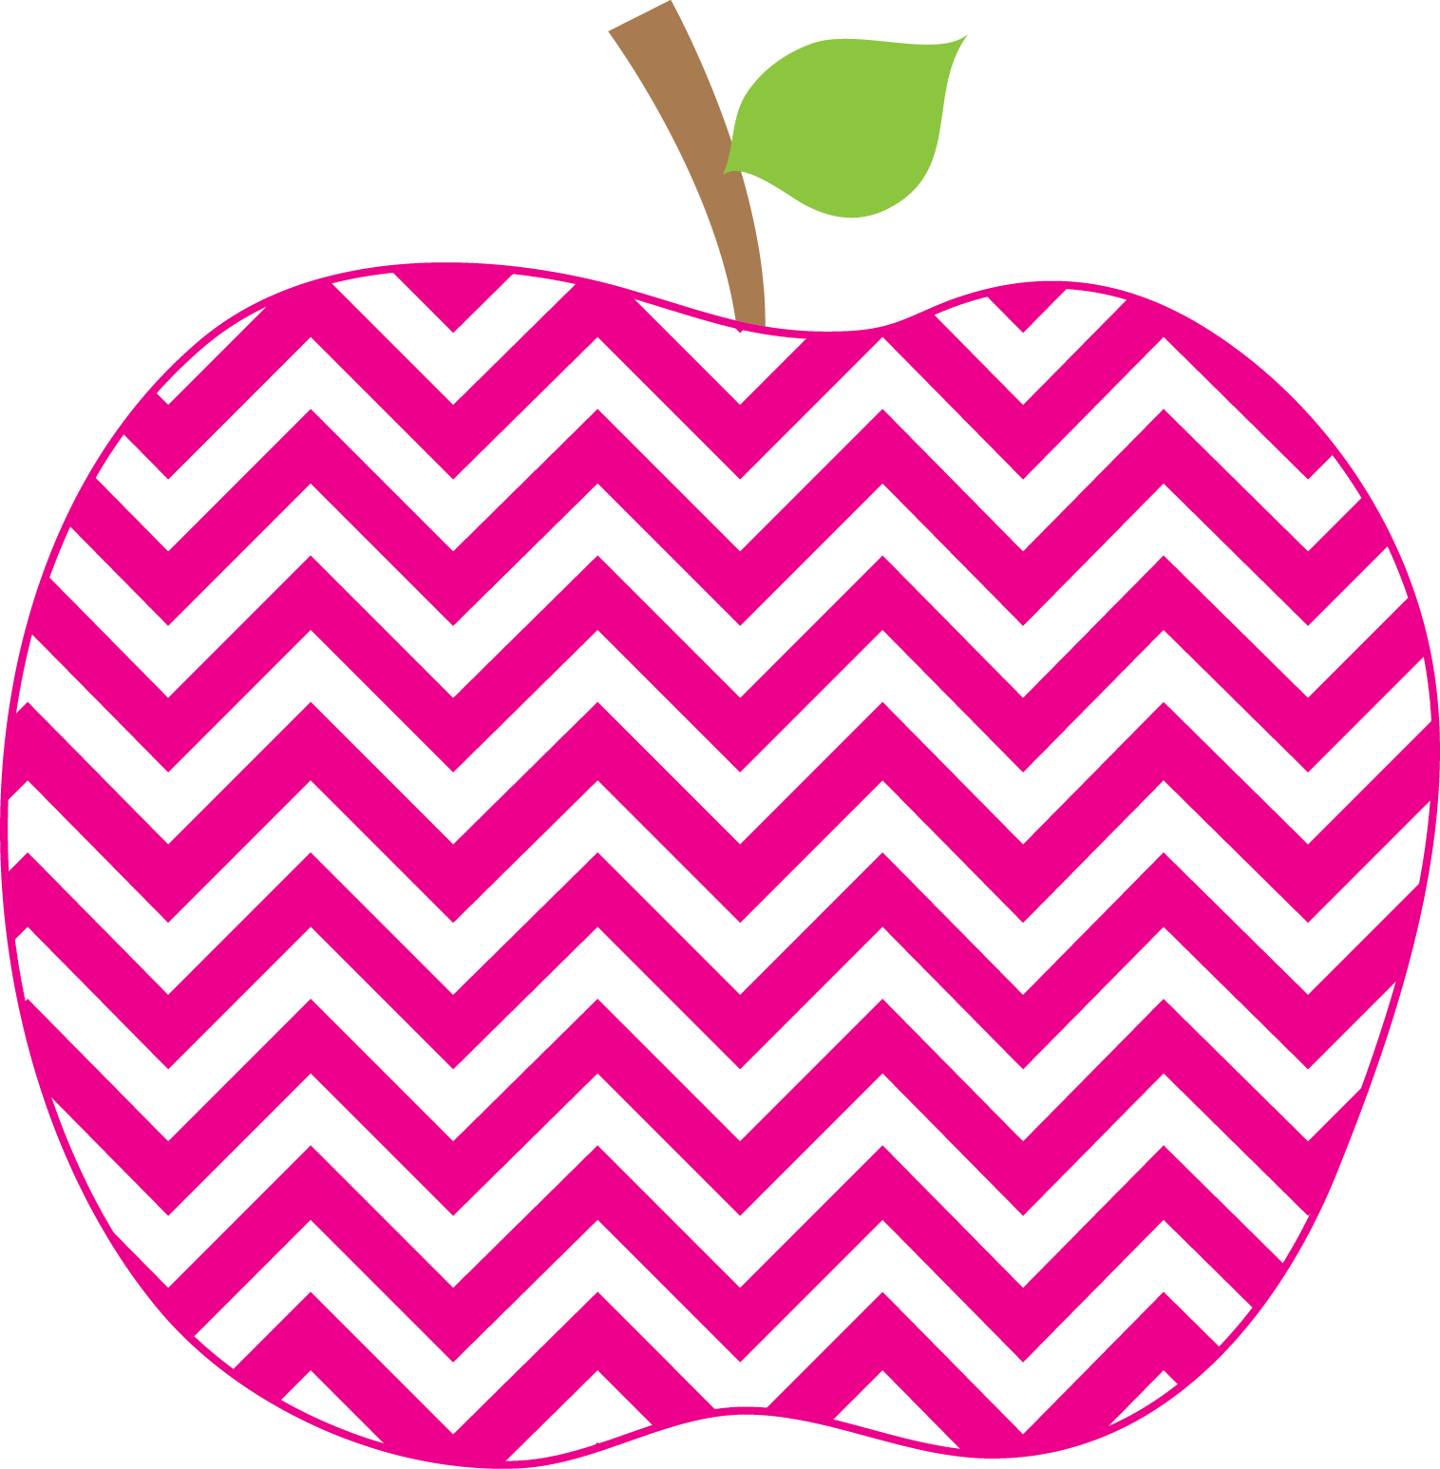

Weekly News

MRS. HOLLOWAY’S CLASS Oct. 31st SSept.12t19Sep16th

Literacy-
This week I am going to focus on the E in CAFÉ, expand vocabulary… tune into interesting words.

The sight words for the week are: what about said up our
Reviewing the name of, sound of and formation of N and E.
Digraphs: ee/ie
The concept of alphabetical order will be taught.
The vowel rule is the cvc rule, consonant, vowel, consonant rule… the vowel sound is the short sound. Ex: bat lit get nut

The Reading Strategy for the week is Flip the Dolphin
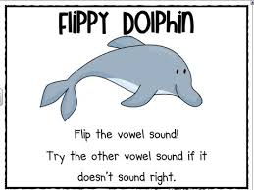

Writing- We will continue to work on the trait, Organization and how our writing pieces should have a beginning, middle and ending. “I can grab my reader’s attention” will be emphasized.
Math-
We are getting to the end of our Unit, Numbers to 20
. counting from a given number
. counting forwards and backwards
. Number neighbours ( before, after, between, more, less )
.Concepts of more and less
. number formation
.number words to ten
.counting by 2’s to 20

Learning Focus for the Week
On Friday if your child would like to dress up in what they would like their career to be, they may do so. It is always fun to see the children excited about what their future could be! One year we even had a student dress as the Prime Minister!

Happy Halloween. I hope that everyone has fun tonight! A treat a day at school is fine, but please remember that healthy choices are encouraged at school.
This is Career Week. I would love to hear from any of you who would like to come in and share your vocation with our students this week. Please email me if interested.
Patti.holloway@nbed.nb.ca
Homework
There is a change in homework this week. I am sending home a Pumpkin Reading passage with comprehension questions to be completed and returned on Thursday. There is a Halloween Math game in the folder as well. These may be kept at home.
Information

